

|  |  |  |  |  |  |
| --- | --- | --- | --- | --- | --- |
| **NAME** |  | | | | |
| **SUBJECT** | **TECHNICAL DRAWING 3 (PRACTICAL)** | **CLASS** | **SS 2** | **DURATION** | **2 ½ HOURS** |

INSTRUCTION: This paper consists of two sections, In section A, answer two questions for 30 marks, question one is compulsory. In section B answer one question for 70 marks.

SECTION A. (30 marks)

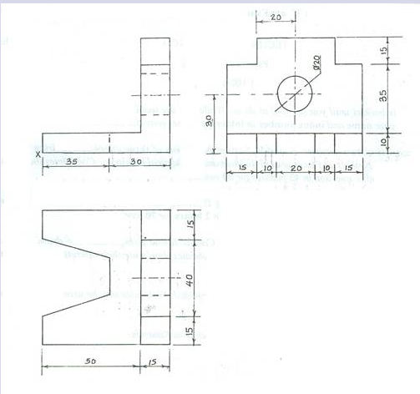

The figure above shows the views of a block in first angle projection. Make a freehand pictorial sketch of the block making X the lowest point.

Technical Drawing 3, WASSCE (PC 2ND), 2018, Q.1 (20 marks)

1. Make a freehand sketch of pictorial view of a claw hammer (10 marks)
2. Make a freehand sketch of pictorial view of a scraper. (10 marks)

WASSCE (SC) Technical drawing 3, 2023 Q. 3

SECTION B (70 marks)

Answer only one question from this section.

1. The drawing below shows the floor plan of a three bedroom bungalow. Study the given specification and answer the questions that follow.

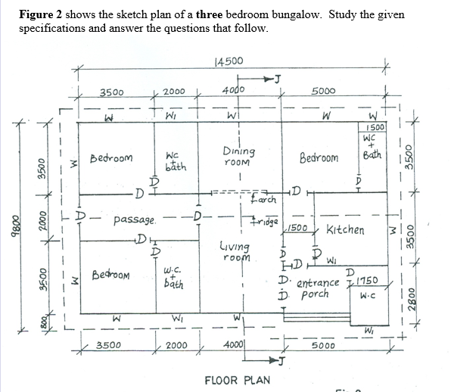

SPECIFICATIONS

All dimensions are given in millimetres.

FOUDATION: 675 x 225 concrete strip foundation on 15 blinding at1000 from ground level.

FLOOR: 200 hardcore, 150 concrete slab, 225 terazzo floor finish;

Floor level is 450 higher than ground level;

Height of floor to ceiling 3100.

STEPS: Riser 150, tread 220.

WALLS: All walls 225 with 12 ceramic tiles wall finish;

DOORS: All doors glazed, three panel in 225 x 50 timber frame.

D. - 2100 x 900 x 38

D.D - 2100 x 1800 x 38

WINDOWS: W – 2000 x 1200 sliding glazed in aluminium frame.

W1 – 900 x 600 top hung casement window, glazed in aluminium frame.

LINTEL: 225 X 225 reinforced concrete at 210 above floor level.

BEAM: 2 Nos. 225 x 225 reinforced concrete at 2,350 above floor level.

ROOF: 350 double pitch;

100 x 50 rafters;

100 x 50 purlins;

100 x 50 struts;

100 x 75 wall plate;

50 x 50 ceiling noggins at 600 centre to centre;

30 x 185 ridge cap;

28 fascia board;

18 soffit board;

900 ves projection.

(a) Draw to a scale of 1: 100, the

(i) floor plan;

(ii) front elevation.

(b) Draw to a scale of 1:50, the sectional view of J – J.

Technical Drawing 3, WASSCE (SC), 2018, Q.4

1. The figure below shows the sketch plan of 3 bedroom bungalow, Study the given specification and answer the questions below

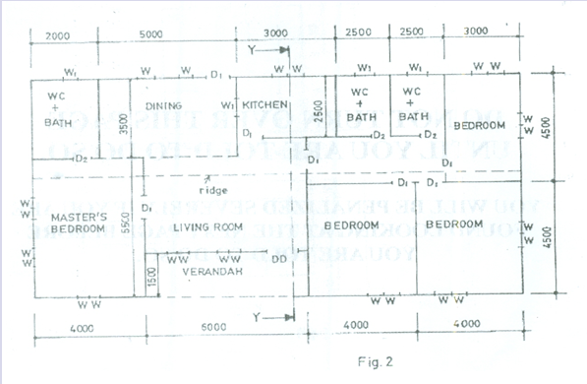

SPECIFICATIONS

All dimensions are given in millimetres.

FOUNDATION: 225 x 675 concrete strip foundation laid over 100 blinding at a depth of 900 below ground level.

FLOOR: 150 hardcore, 150 concrete slab, 25 mortar screed, finish floor level to ceiling 3150.

WALLS: All walls 225.

LINTELS: 225 X 225 reinforced concrete.

DOORS: All doors 2100 x 900 x 40 flush wooden in 100 x 50 timber frame except at verandah with glazed double door, 2100 x 1500 x 40 in aluminium frame.

WINDOWS: Sliding glass in aluminium frames, bath W.C. and store windows 600 x 600, others 900 x 1200.

BEAM: 225 x 225 reinforced concrete, 2400 above floor level.

COLUMN: 225 X 225 reinforced concrete.

ROOF: 25o double pitch with eaves 600 and corrugated asbestos sheets, timber rafter 1000 x 50 at 1000 centres, fascial board 25 x 250.

(Assume unspecified dimension)

Draw to a scale of 1:100 the:

Floor plan;

Front Elevation;

Draw to a scale of 1:50, the sectional view on plane Y–Y.

Technical Drawing 3, WASSCE (PC 2ND), 2019, Q. 4